USER MANUAL

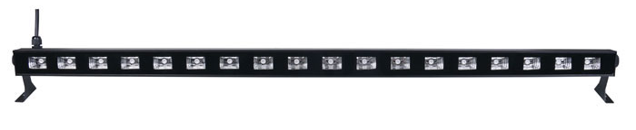

Thank you for purchasing our light, please read user guide for safety and operations before using. Keep this manual for future reference.

Safety instructions

- Please keep this User Manual for future consultation. If you sell the fixture to another user, be sure that they also receive this instruction booklet.
- Please unpack and check carefully there is no transportation damage before using the fixture.
- Please disconnect main power before servicing and maintenance.
- The unit must be installed in a location with adequate ventilation, at least 50cm from adjacent surfaces.Be sure that no ventilation slots are blocked.
- The maximum ambient temperature is Ta:40°C. DO NOT operate it where the temperature is higher than this.
- DO NOT connect the device to any dimmer pack.
- The housing must be replaced if they are visibly damaged.
- Unit surface temperature may reach up to 85°C. Don’t touch the housing bare-hand during its operation. Turn off the power and allow about 15 minutes for the unit to cool down before replacing or serving.
- There are no user serviceable parts inside the fixture. Do not open the housing or attempt any repairs by yourself. In the unlikely event your fixture may require service, please contact your nearest dealer.
- In the event of serious operating problem, stop using the fixture
- Immediately. Never try to repair the fixture by yourself. Repairs carried out by unskilled people can lead to damage or malfunction. Please contact the nearest authorized technical assistance center. Always use the same type spare parts.
- Unpack the device. Inside the box you should find:
Name | Quantity | Unit
light | 1 | PC
User manual | 1 | PC

Hanging
1.The applicable temperature for the lighting is between -25°C to 40°C. Do not use the lighting under or above the temperature.
2.The installation has to be built and constructed in a way that it can hold 10 times the weight for 1 hour without any harming deformation.
3. The installation must always be secured with a secondary safety attachment, e.g. an appropriate safety rope.Never stand directly below the device when mounting, removing or servicing the fixture.
4. The operator has to make sure the safety relating and machine technical installations are approved by an expert before taking the device into operation for the first time.

TECHNICAL DATA

Input voltage: AC100-240V 50/60Hz
Power consumption: 30W
IP rating：IP20
Max ambient temperature：45℃
LED: 18*3W Jingxing UV LED, 398nm
Light size: 130*50*1000MM
N.W.：1KG

